Problem Set 7
Code:
module convolutional_encoder(
clk_in,
start_in,
data_in,
done_out,
fec_out
);

// This is the input clk, clk_in
input clk_in;
// This is the input start signal, start_in
input start_in;
// This is the input data signal, data_in
// it is cereal.
input data_in;
// This is the done output signal
output done_out;
// This is the 96 bit fec output signal
// given 48 bits input this block produces 2 outputs per input
// 48 * 2 is 96
output [95:0] fec_out;

// This is the local parameter window size
localparam WIN_SIZE = 4;
// This is the count value which we start decrementing from
// After 48 input cycles we are done
localparam DONE_COUNT = 48;

// This is the input data shift register. It is size 4 because
// we need x[n-3]
reg [WIN_SIZE-1:0] data_in_sr = 'b0;
// This is the start state
reg started = 1'b0;
// This is the 96 bit fec output signal
// given 48 bits input this block produces 2 outputs per input
// 48 * 2 is 96
reg [95:0] fec_out = 96'b0;
// This is the counter to determine the number of bits in the shift
// register
reg [5:0] counter = DONE_COUNT;

// This is a wire of P_0[n]
wire p0;
// This is a wire for P_1[n]
wire p1;

// This assigned the P_0[n] value to the value specified in the Pset
assign p0 = data_in ^ data_in_sr[0] ^ data_in_sr[1] ^ data_in_sr[2];
// This assigned the P_1[n] value to the value specified in the Pset
assign p1 = data_in ^ data_in_sr[1] ^ data_in_sr[2];
// We are done once the count hits 0
assign done_out = ~(|counter);

//This is an always block so stuff is synchronous
always @(posedge clk_in)
// This is the begin statement to look nice
begin
// This is an if statement which tells us to start if we
// get told to start but haven't started yet
if ((~started) & start_in)
// This is a begin statement to look nice
begin
// This is the beginning value of the counter
counter <= DONE_COUNT;
// This initialised the fec_out to 0
fec_out <= 96'b0;
// This tells us later that we have started
started <= 1'b1;
// This is the shift in the shift register
data_in_sr <= {data_in_sr[3:0], data_in};
// This is an end statement for the if statement begin
end
// This is te check if we have started but aren't done yet
else if (started & (~done_out))
// This is the begin statement to look nice
begin
// This is the decrement of the counter
counter <= counter - 1;
// This is the filling up of the fec register
// We fill from the LSB
fec_out <= {fec_out[93:0], p1, p0};
// This shifts the data into the shift register
// We fill from the LSB
data_in_sr <= {data_in_sr[3:0], data_in};
// This is an end statement from the else if
end
// This is the end statement for the always block
end
// This is an endmodule for the convolutional_encoder module
endmodule

Testbench:
module convolutional_encoder_tb;
// This is the count value which we start decrementing from
// After 48 input cycles we are done
localparam DONE_COUNT = 48;
// This is the clock
reg clk = 1'b0;
// This is the start signal
reg start = 1'b0;
// This is the data signal
reg data = 1'b0;
// This is the done output signal
wire done;
// This is the output of the FEC encoder
wire [95:0] fec;
// This is the instantiation of the FEC encoder
convolutional_encoder ce1(
.clk_in (clk),
.start_in (start),
.data_in (data),
.done_out (done),
.fec_out (fec)
);
// This is the input test data
reg [DONE_COUNT-1:0] data_sr = 48'h03010203303A;
// This ensures that we haven't started yet, so do not
// shift data in
reg started = 1'b0;

// alonzi
initial
begin
// This is so we can plot stuff in vcd viewer
$dumpfile("test.vcd");
// This is so we can see all the signals
$dumpvars(0, convolutional_encoder_tb);
// This tells the dut to start
start = 0;
#10;
start = 1;
// This is some delay so we get some output
#500;
// This is to deassert and make sure the
// output stays fixed
start = 0;
#10;
// bye bye
$finish;
end

// This is the always block where we shift in the cereal data
always @(posedge clk)
begin
// if we start or have started
if ( (~done) & (start | started))
begin
// This is so we know next clock tick that we have started
started <= 1'b1;
// This puts the cereal into out encoder
data <= data_sr[DONE_COUNT-1];
// This makes the cereal data
data_sr <= {data_sr[DONE_COUNT-2:0], 1'b0};
end
end
// This is how we clock
always #5 clk = ~clk;
endmodule

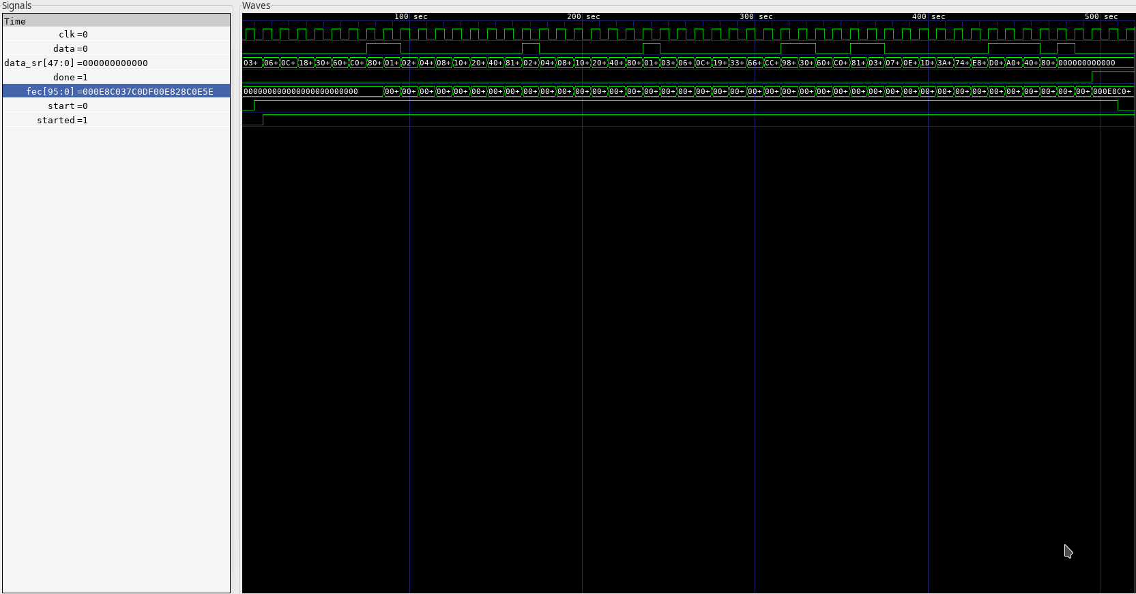
Screenshot:

